**Day-12 Full Stack**

**Html**

<!DOCTYPE html>

<html lang="en">

  <head>

    <meta charset="UTF-8" />

    <meta name="viewport" content="width=device-width, initial-scale=1.0" />

    <title>Document</title>

    <link rel="stylesheet" href="style.css" />

  </head>

  <body>

    <div class="container">

      <div class="header">header</div>

      <div class="content">content</div>

      <aside class="aside1">aside</aside>

      <aside class="aside2">aside</aside>

      <footer class="footer">footer</footer>

    </div>

  </body>

</html>

**Css**

.container {

}

.container > * {

}

.header {

  background-color: aqua;

}

.content {

  background-color: blue;

}

.aside1 {

  background-color: brown;

}

.aside2 {

  background-color: chartreuse;

}

.footer {

  background-color: darkgoldenrod;

}

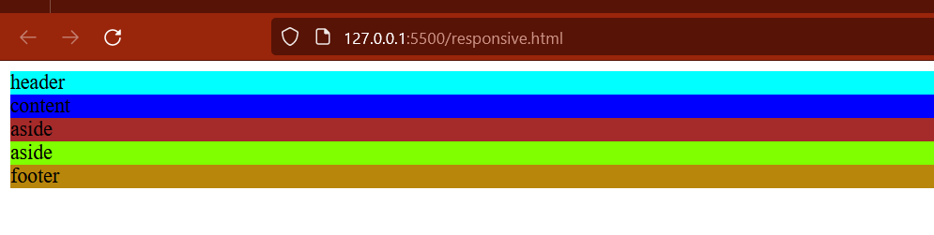

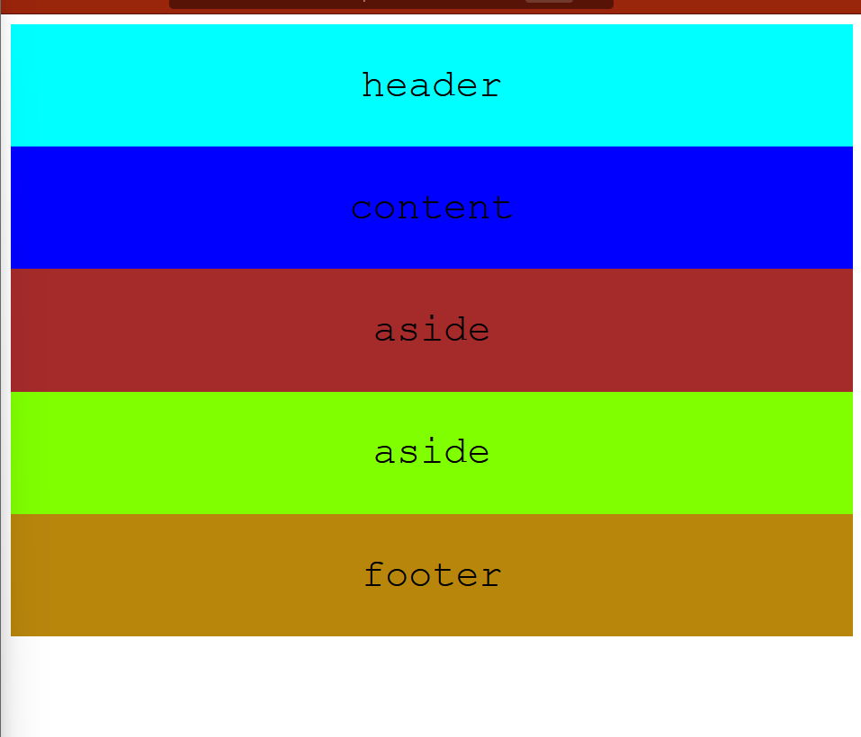

.container {

  font-family: 'Courier New', Courier, monospace;

  text-align: center;

  font-size: 2rem;

  display: flex;

  /* background-color: black; */

  flex-flow: row wrap;

}

.container > * {

  padding: 2rem;

  /* grow shrink basis */

  flex: 0 1 100%;

}

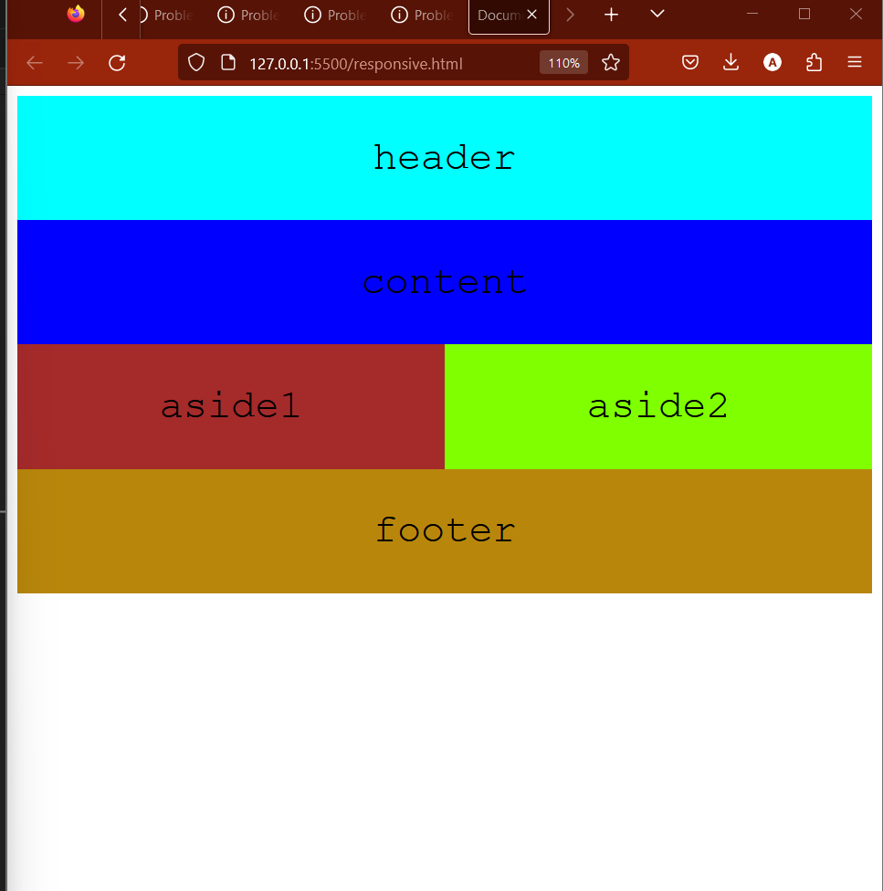

@media (min-width: 600px) {

  .aside {

    flex: 1 0 0%;

  }

}

**Use of Order Property;**

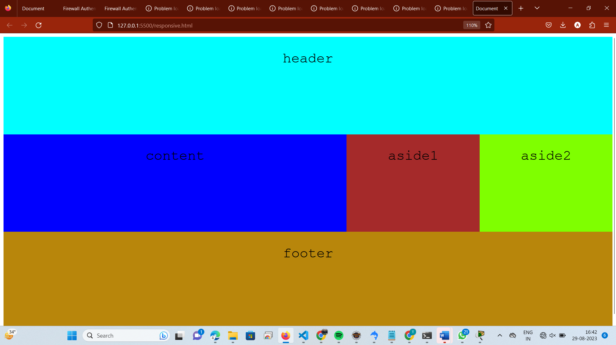

**Header: 20% height;**

**Content aside: 70% height;**

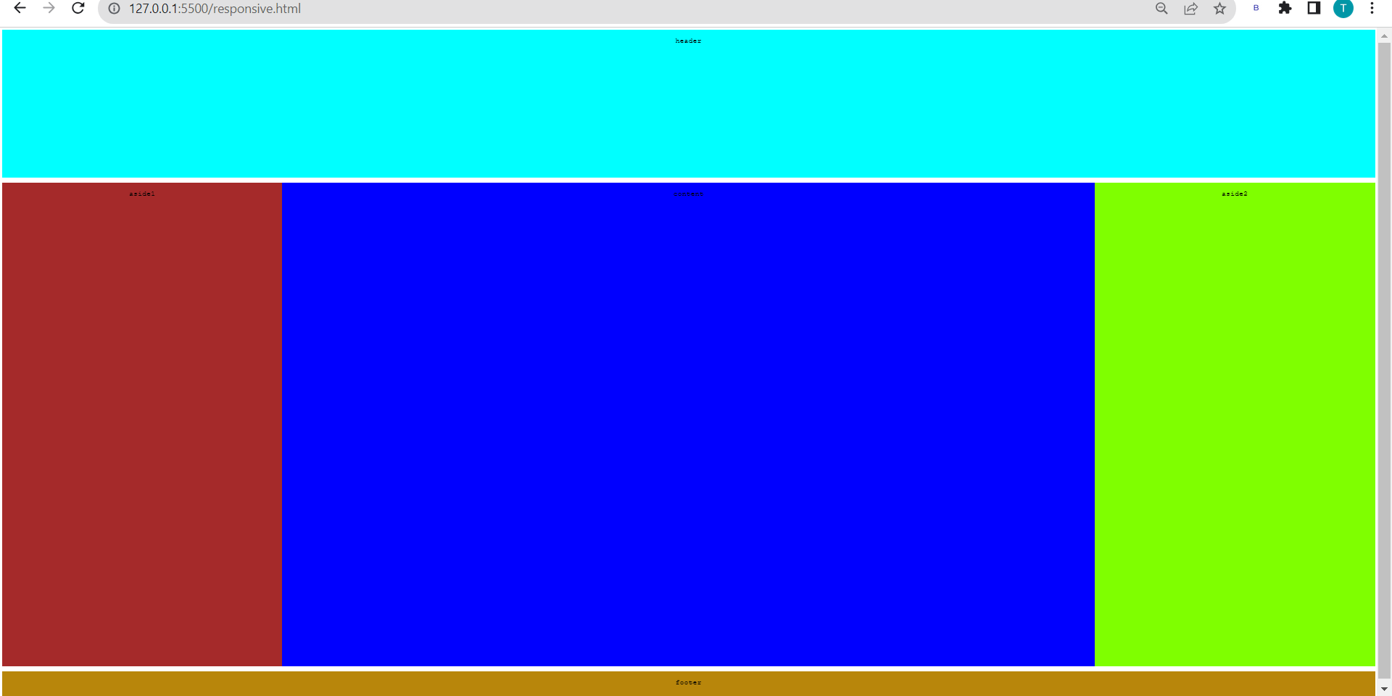

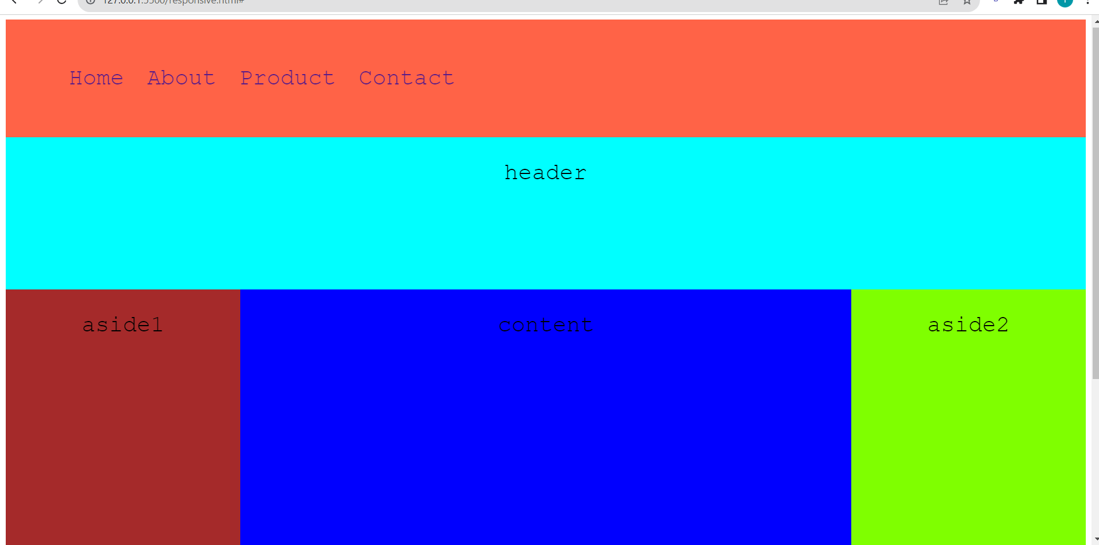

**Style.css**

.container {

  font-family: 'Courier New', Courier, monospace;

  text-align: center;

  font-size: 2rem;

  display: flex;

  /* background-color: black; */

  flex-flow: row wrap;

  height: 100vh;

}

.container > * {

  padding: 2rem;

  /* grow shrink basis */

  flex: 0 1 100%;

}

.header {

  background-color: aqua;

  height: 20%;

}

.nav {

  background-color: tomato;

}

nav ul {

  display: flex;

  justify-content: start;

}

nav ul li {

  list-style-type: none;

}

nav ul li a {

  text-decoration: none;

  padding: 0px 1rem;

}

.content {

  background-color: blue;

  height: 70%;

}

.aside1 {

  background-color: brown;

  height: 70%;

}

.aside2 {

  background-color: chartreuse;

  height: 70%;

}

.footer {

  background-color: darkgoldenrod;

}

@media (min-width: 600px) {

  .aside {

    flex: 1 0 0%;

  }

}

@media (min-width: 1024px) {

  .content {

    flex: 3 0 0%;

  }

  .container {

    .header {

      order: 1;

    }

    .aside1 {

      order: 2;

    }

    .content {

      order: 3;

    }

    .aside2 {

      order: 4;

    }

    .footer {

      order: 5;

    }

  }

}

**Grid:**

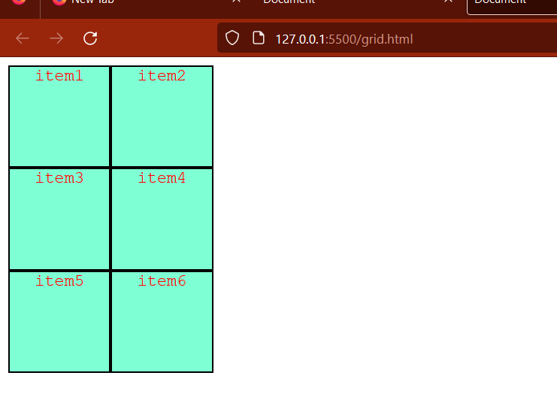

.container {

  text-align: center;

  font-family: 'Courier New', Courier, monospace;

  display: grid;

  /* grid-template-columns: 100px 100px 100px; */

  /* grid-template-rows: 100px 100px; */

  grid-template-columns: 100px 100px;

  grid-template-rows: 100px 100px 100px;

}

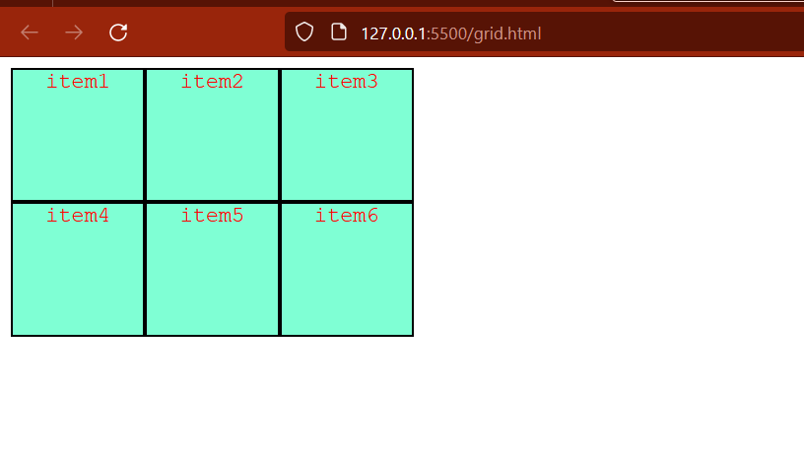

.container {

  text-align: center;

  font-family: 'Courier New', Courier, monospace;

  display: grid;

  grid-template-columns: 100px 100px 100px;

  grid-template-rows: 100px 100px;

  /* grid-template-columns: 100px 100px;

  grid-template-rows: 100px 100px 100px; */

}

.container > * {

  background-color: aquamarine;

  color: red;

  border: 2px solid black;

}

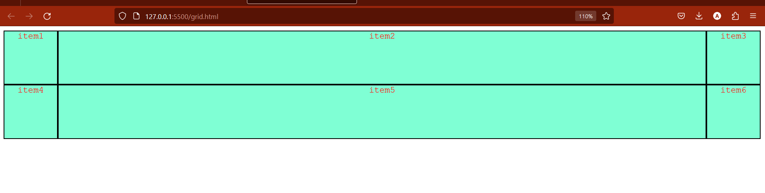

.container {

  text-align: center;

  font-family: 'Courier New', Courier, monospace;

  display: grid;

  grid-template-columns: 100px auto 100px;

  grid-template-rows: 100px 100px;

  /* grid-template-columns: 100px 100px;

  grid-template-rows: 100px 100px 100px; */

}

.container > * {

  background-color: aquamarine;

  color: red;

  border: 2px solid black;

}

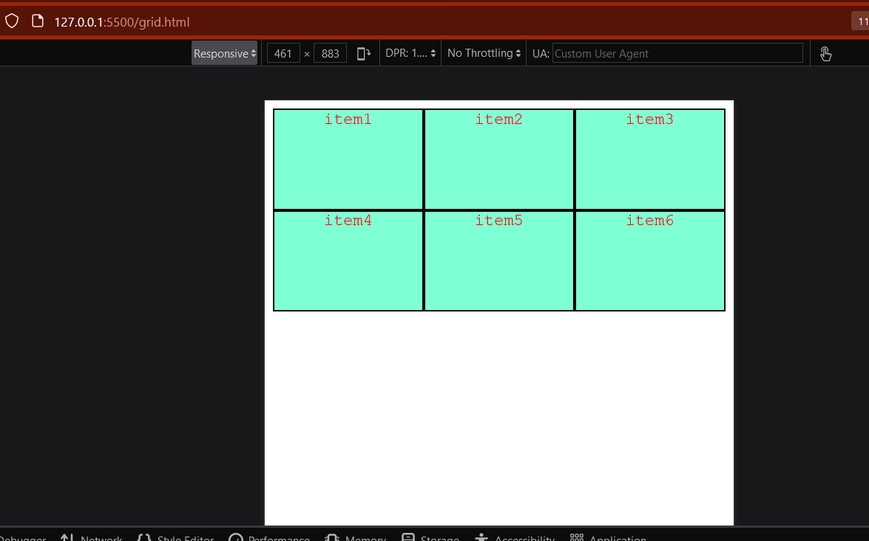

.container {

  text-align: center;

  font-family: 'Courier New', Courier, monospace;

  display: grid;

  grid-template-columns: 1fr 1fr 1fr;

  grid-template-rows: 100px 100px;

  /* grid-template-columns: 100px 100px;

  grid-template-rows: 100px 100px 100px; */

}

.container > * {

  background-color: aquamarine;

  color: red;

  border: 2px solid black;

}

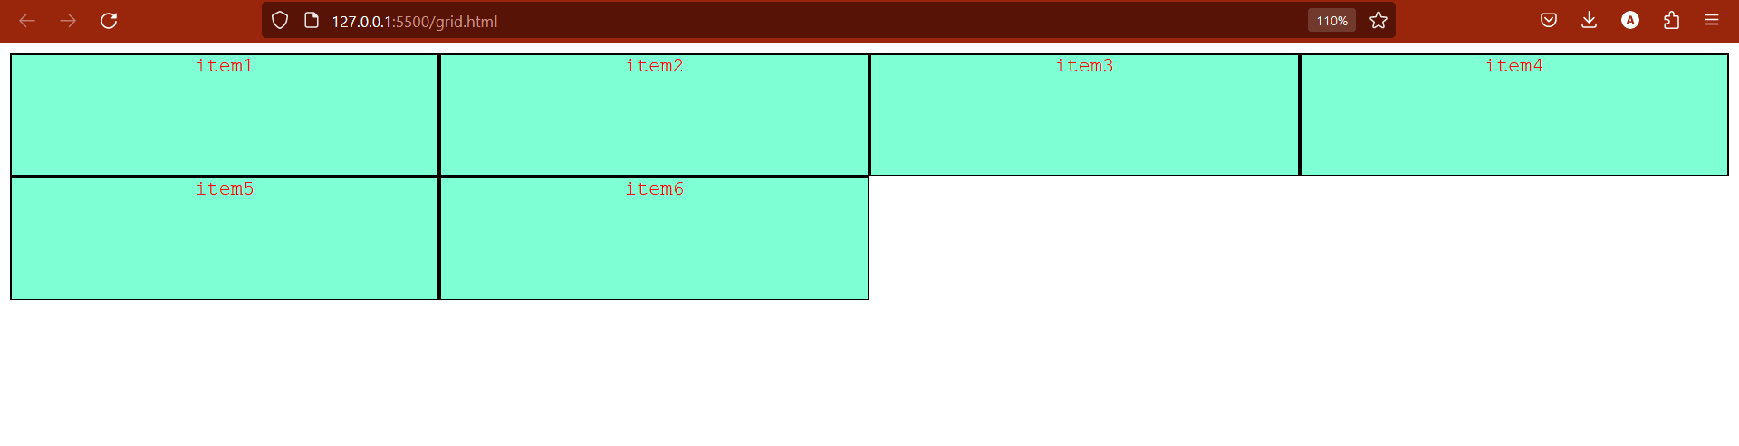

.container {

  text-align: center;

  font-family: 'Courier New', Courier, monospace;

  display: grid;

  grid-template-columns: repeat(4, 1fr);

  grid-template-rows: 100px 100px;

  /* grid-template-columns: 100px 100px;

  grid-template-rows: 100px 100px 100px; */

}

.container > * {

  background-color: aquamarine;

  color: red;

  border: 2px solid black;

}

**Day-13 Full Stack**

<!DOCTYPE html>

<html lang="en">

  <head>

    <meta charset="UTF-8" />

    <meta name="viewport" content="width=device-width, initial-scale=1.0" />

    <title>Document</title>

    <link rel="stylesheet" href="style.css" />

  </head>

  <body>

    <div class="container">

      <div class="header">header</div>

      <div class="menu">menu</div>

      <div class="content">content</div>

      <div class="footer">footer</div>

    </div>

  </body>

</html>

**Css:**

.container {

  height: 90vh;

  display: grid;

  grid-template-columns: repeat(12, 1fr);

  grid-template-rows: 100px auto 100px;

  background-color: aqua;

}

.container > * {

  background-color: antiquewhite;

  border: 2px solid black;

}

.header {

  grid-column: 2/-1;

}

.footer {

  grid-column: 1/-1;

}

.content {

  grid-column: 2/-1;

}

.menu {

  grid-row: 1/-2;

}

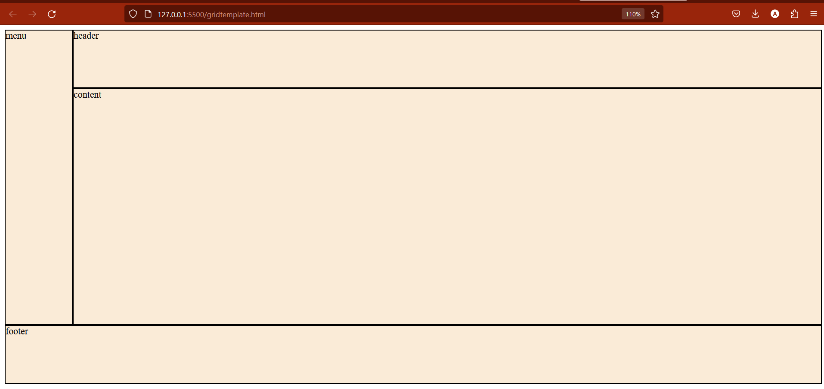

**==**

**Grid-template-areas:**

.container {

  height: 90vh;

  display: grid;

  grid-template-columns: repeat(12, 1fr);

  /* grid-template-rows: 100px auto 100px; */

  grid-template-areas:

    'm m h h h h h h h h h h '

    'm m c c c c c c c c c c'

    'f f f f f f f f f f f f';

  background-color: aqua;

}

.container > * {

  background-color: antiquewhite;

  border: 2px solid black;

}

.header {

  grid-area: h;

  /* grid-column: 2/-1; */

}

.footer {

  grid-area: f;

  /* grid-column: 1/-1; */

}

.content {

  grid-area: c;

  /* grid-column: 2/-1; */

}

.menu {

  grid-area: m;

  /* grid-row: 1/-2; */

}

.container {

  height: 90vh;

  display: grid;

  grid-template-columns: repeat(12, 1fr);

  grid-template-rows: 100px auto 100px;

  grid-template-areas:

    'm m h h h h h h h h h h '

    'm m c c c c c c c c c c'

    'f f f f f f f f f f f f';

  background-color: aqua;

}

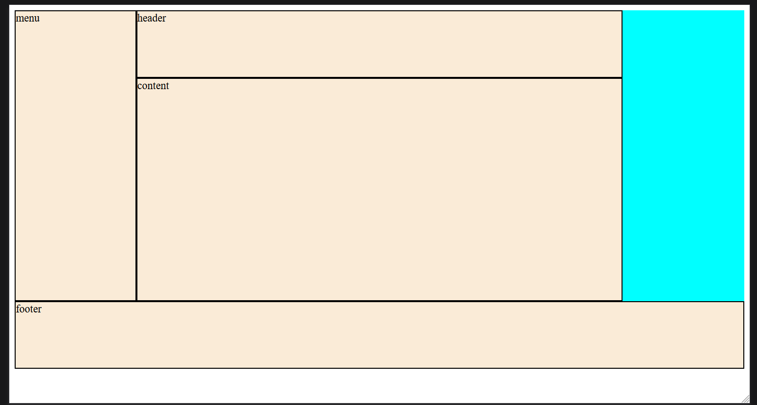

.container {

  height: 90vh;

  display: grid;

  grid-template-columns: repeat(12, 1fr);

  grid-template-rows: 100px auto 100px;

  grid-template-areas:

    'm m h h h h h h h h . . '

    'm m c c c c c c c c . .'

    'f f f f f f f f f f f f';

  background-color: aqua;

}

.container > * {

  background-color: antiquewhite;

  border: 2px solid black;

}

.header {

  grid-area: h;

  /* grid-column: 2/-1; */

}

.footer {

  grid-area: f;

  /* grid-column: 1/-1; */

}

.content {

  grid-area: c;

  /* grid-column: 2/-1; */

}

.menu {

  grid-area: m;

  /* grid-row: 1/-2; */

}

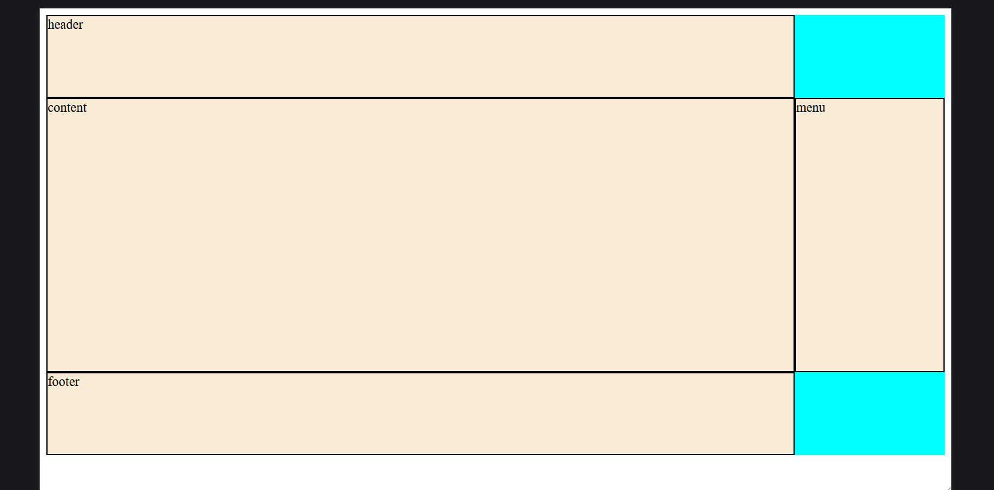

.container {

  height: 90vh;

  display: grid;

  grid-template-columns: repeat(12, 1fr);

  grid-template-rows: 100px auto 100px;

  grid-template-areas:

    'h h h h h h h h h h . .'

    'c c c c c c c c c c m m'

    'f f f f f f f f f f . .';

  background-color: aqua;

}

Auto-fit:

.container {

  height: 90vh;

  display: grid;

  font: 20px cursive;

  grid-template-columns: repeat(auto-fit, minmax(100px, 1fr));

  grid-template-rows: 100px;

  grid-auto-rows: 100px 100px;

  background-color: aqua;

}

.container > * {

  background-color: antiquewhite;

  border: 2px solid black;

}

**Grid Revision:**

1)display:grid;



2)grid-template-columns:auto auto auto auto;

.container {

  display: grid;

  grid-template-columns: auto auto auto auto;

}

.container > * {

  background-color: bisque;

  border: 2px solid black;

}



.container {

  display: grid;

  grid-template-columns: 800px auto 40px;

  grid-template-rows: auto auto auto auto;

}

.container > * {

  background-color: bisque;

  border: 2px solid black;

}

**3)column-gap:**

**4)row-gap:**

.container {

  display: grid;

  grid-template-columns: auto auto auto auto;

  column-gap: 50px;

  row-gap: 70px;

}

.container > * {

  background-color: bisque;

  border: 2px solid black;

}

5)Shorthand property for gap:

=>gap: 50px 100px; /* gap: row column; */

.container {

  display: grid;

  grid-template-columns: auto auto auto auto;

  gap: 50px 100px;

}

.container > * {

  background-color: bisque;

  border: 2px solid black;

}

6)grid-templates-row:

.container {

  display: grid;

  grid-template-columns: auto auto auto;

  grid-template-rows: auto auto auto auto;

}

7.justify-content:

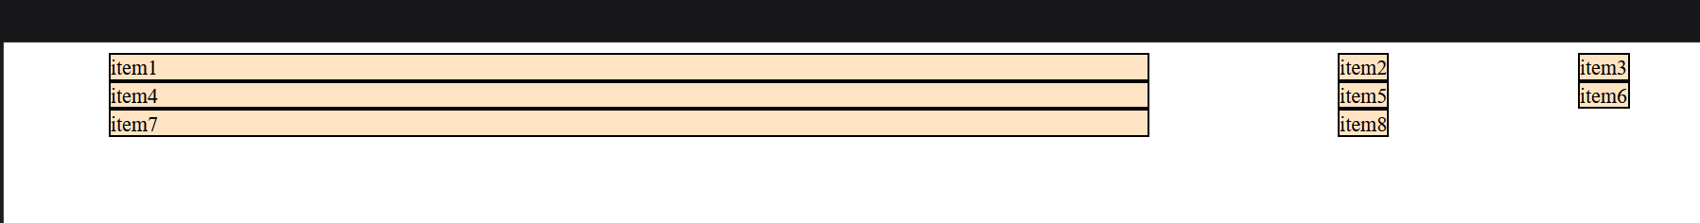

.container {

  display: grid;

  grid-template-columns: 800px auto 40px;

  grid-template-rows: auto auto auto auto;

  justify-content: space-around;

}

8.align-content property

.container {

  display: grid;

  grid-template-columns: 800px auto 40px;

  grid-template-rows: auto auto auto auto;

  justify-content: space-around;

  align-content: center;

  height: 100vh;

}

**Grid Line:**

**Child Property:**

**1)grid-column-start: 2;**

**2)grid-column-end:4;**

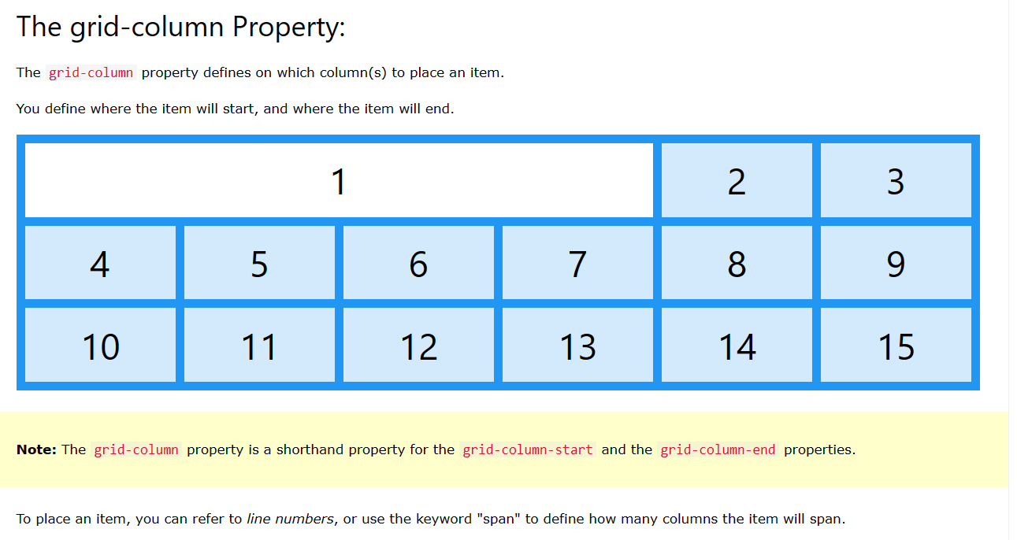

.container {

  display: grid;

  grid-template-columns: auto auto auto;

}

.container > * {

  background-color: bisque;

  border: 2px solid black;

}

.item-1 {

  grid-column-start: 2;

  grid-column-end: 4;

}

**=>**grid-column is shorthand of grid-column-start and grid-column-end

.item-1 {

  background-color: blueviolet;

  grid-column: 1 / span 3;

}

.item-1 {

  background-color: blueviolet;

  grid-column: 1 / 3;

}

**3)grid-row-start:**

**4)grid-row-end:**

**Que1)When I provide grid-column-start and grid-column-end then leave space whatever I left but whenever I add grid-row-start and grid-row-end all leave space occupied.**



.item-1 {

  grid-column-start: 2;

  grid-column-end: 4;

  /* grid-row-start: 1;

  grid-row-end: 3; */

}



.item-1 {

  grid-column-start: 2;

  grid-column-end: 4;

  grid-row-start: 1;

  grid-row-end: 3;

}

**6)**

**=>**grid-row:

.item-1 {

  background-color: blueviolet;

  grid-row: 1/3;

}

.item-1 {

  background-color: blueviolet;

  grid-row: 1 / span 3;

}

7)grid-area:

.item-1 {

  background-color: blueviolet;

  grid-area: 1/2/3/4;

}

**CSS:**

.container {

  display: grid;

  grid-template-areas:

    'h h h h h h '

    'm m c c c c'

    'm m c c c c'

    'f f f f f f';

  text-align: center;

  height: 100vh;

}

.header {

  background-color: antiquewhite;

  grid-area: h;

}

.menu {

  background-color: aquamarine;

  grid-area: m;

}

.content {

  background-color: burlywood;

  grid-area: c;

}

.footer {

  background-color: darkolivegreen;

  grid-area: f;

}

**Html**

   <div class="container">

      <div class="header">header</div>

      <div class="menu">menu</div>

      <div class="content">content</div>

      <div class="footer">footer</div>

    </div>

.container {

  display: grid;

  grid-template-areas:

    'h h h h . . '

    'm m c c c c'

    'm m c c c c'

    'f f f f f f';

  text-align: center;

  height: 100vh;

}

